Calling All Earthdoggers

Ontario is the place to be this June!!!

5 titling opportunities

The Dachshund Club of Greater Ontario is holding two CKC Earthdog Tests on June 15th-16th.

Location: Laurelwood Earthdog Centre, near Pontypool ON.

Classes offered: Intro to Quarry, Junior, Senior and Master

Then!!!

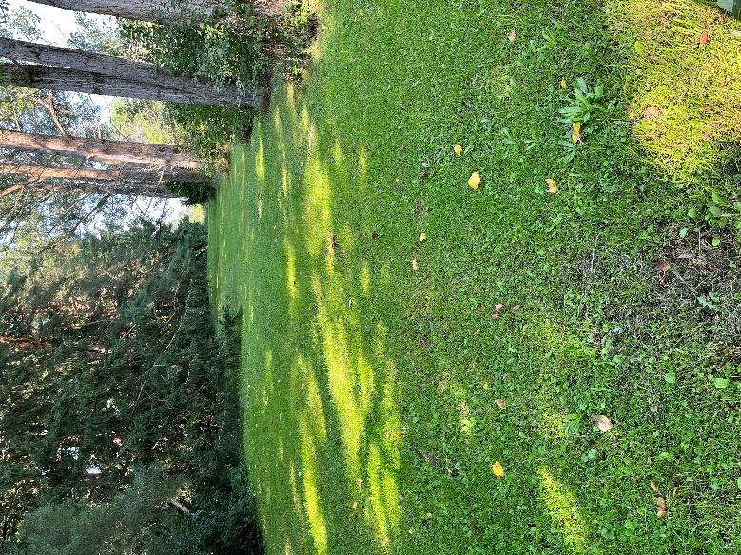Border Terrier Canada and the Border Terrier Club of Ontario are combining forces for a

Canada day weekend extravaganza!!!

There will be a practice/training day for all levels on Saturday June 29th.

Two CKC Earthdog tests on June 30th along with a BBQ lunch.

One CKC Earthdog Test on July 1st.

Classes offered: Intro to Quarry, Novice, Junior, Senior, Advanced, Master.

Location: Our new and exciting Earthdog site on Lakeridge Road, Sunderland ON.

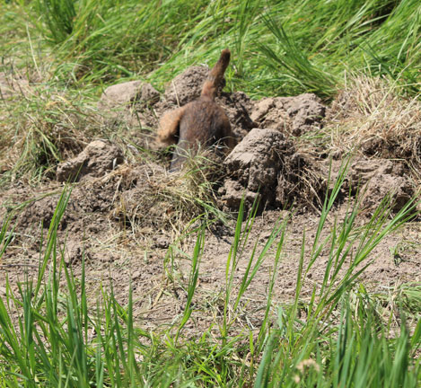This site offers ample parking with shade, fenced dens (Intro thru Senior) and lovely Master walk ups.

For those of you with Junior or Senior titled dogs, the five tests over three weekends will offer you the opportunity to earn the new Grand Junior Earthdog (GJE) or

Grand Senior Earthdog (GSE) titles.

Full information on both weekends will be available on Canuck Dogs and online entries will be available through The Entry Line.

We look forward to seeing seasoned earthdoggers and a whole new raft of newcomers.

Come on out, your Borders will love you for it.

For additional information on the BTC/BTCO Tests contact our trial secretary:

Shawn Froese [sfroese@sympatico.ca](mailto:sfroese@sympatico.ca)